**Project Design Phase-II**

**Technology Stack (Architecture & Stack)**

|  |  |
| --- | --- |
| Date | 26 January 2025 |
| Team ID | LTVIP2025TMID49340 |
| Project Name | Cosmetic insights |
| Maximum Marks | 4 Marks |

**Technical Architecture:**

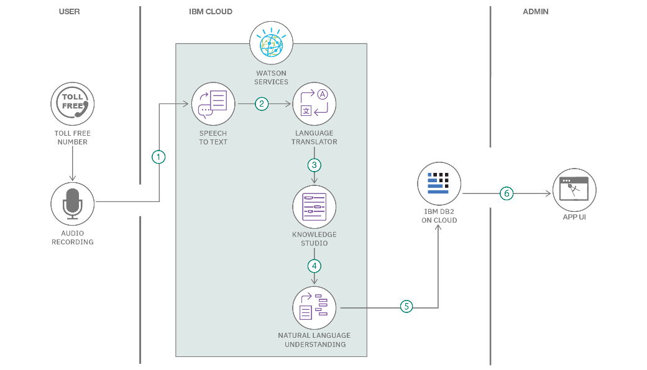

**References:**

### Table-1: Components & Technologies

| **S.No** | **Component** | **Description** | **Technology** |
| --- | --- | --- | --- |
| 1 | User Interface | Interactive dashboards to view cosmetic trends and sentiments | Tableau Public |
| 2 | Application Logic-1 | Data cleaning and transformation of cosmetic video metadata | Python (Pandas, NumPy) |
| 3 | Application Logic-2 | Sentiment analysis on titles and tags | Python (TextBlob / NLTK) |
| 4 | Application Logic-3 | Dashboard logic: Interactivity using filters and parameters | Tableau Filters, Actions, Parameters |
| 5 | Database | Flat file data from multiple countries | CSV |
| 6 | Cloud Database | Cloud-based storage for datasets | Google Drive / OneDrive |
| 7 | File Storage | Stores cleaned, processed datasets | Local File System / Cloud Storage |
| 8 | External API-1 | Used for accessing YouTube metadata (views, likes, etc.) | YouTube Data API |
| 9 | Machine Learning Model | For analyzing sentiment from textual video metadata | Pretrained models (TextBlob / VADER Sentiment) |
| 10 | Infrastructure | Deployment of dashboards and reports | Tableau Public / Tableau Cloud |

**Table-2: Application Characteristics:**

| **S.No** | **Characteristics** | **Description** | **Technology** |
| --- | --- | --- | --- |
| 1 | Open-Source Frameworks | Yes; used Python libraries and Tableau Public | Tableau Public, Python |
| 2 | Security Implementations | Public dashboard, no sensitive data; admin-only control of dataset upload | Basic access restriction |
| 3 | Scalable Architecture | Can be scaled by migrating to Tableau Cloud or other BI platforms | Tableau Cloud |
| 4 | Availability | Dashboards accessible online 24/7 | Tableau Public |
| 5 | Performance | Optimized dashboards with filters and KPIs for fast load and interaction | Tableau Features |